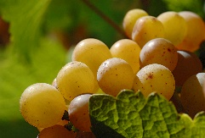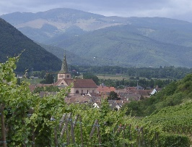

**Appellation :** AOC Crémant d’ALSACE

**Grape variety :** Pinot Blanc, Auxerrois

Pinot Blanc (apples, flowery, creamy) – Pinot Auxerrois (musky, buttery, spicy, honeyed, apricot, orange blossom, tangerine peel) two varieties of the same family, traditionnaly vinificated together.

**Soil :** Sandy and gravely soil

**Vinification :** Cremant d’Alsace is produced under the rules of the « Champagne Method ». Strict selection of the grapes, special cellar equipements, second fermentation in bottle, no filtration but « degorgement », 24 months of aging on lees before selling.

**Analysis :** Non Vintage

Alcohol % : 12 %

Residual Sugar g/l : 2.4

Total Acidity g/l H2So4 : 4.20

Volatile Acidity g/l H2So4 : 0.3

**Quality and character :**

White fruit aromas (pear, apple), with hints of dry fruit, white blossoms and brioche. An elegant, gently sparkling wine with fruity freshness

**Temperature of service :** 8 to 10°c

**Prime drinking :** 2 to 3 years

**Food matching :**Elegant aperitif, seafood, entrees, poultry, pastry, white meat, ideal for any nice drinking occasion

**Awards :**

Wine Enthusiast : 92 points (December 2017)

Jamessuckling.com : 90 points (guide 2017/2018)

EAN bouteille : 3 274 550 070 760

EAN carton : 3 274 550 070 708

Crémant d’Alsace Mayerling Brut

