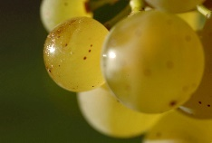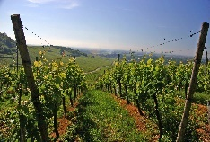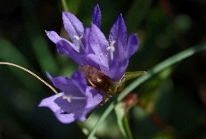

**Appellation :** AOC ALSACE

**Grape variety :** 100 % Gewurztraminer

The most aromatic of Alsace Wines. Gewurztraminer is a grape that has a low level of acidity. Classic Gewurztraminer has almost legendary potential longevity.

**Soil :** Limestone, granite, gravel, marl and sandstone

**Vinification :** Traditional in stainless steel tank, fermentation temperature of 19°C.

**Analysis :** vintage 2021

Alcohol % : 13.5%

Residual Sugar g/l : 14.8

Total Acidity g/l H2So4 : 3.6

**Quality and character :**

Light yellow in color. Typical gewürztraminer nose. A wine of great finesse, ripeness and varietal purity, with fragrant rose-petal and exotics fruits aromas . Well balanced.

**Temperature of service :** 8 to 10°c

**Prime drinking :** 2 to 3 years

**Food matching :** Ideal apéritif, which also goes very well with spicy or exotic cuisine, strong cheeses (blue cheese, Munster), desserts.

Gewurztraminer Bio

Jardin de Trebogad

