**Appellation :** AOC ALSACE

**Grape variety :** 100 % Gewurztraminer

The most aromatic of Alsace Wines. Gewurztraminer is a grape that has a low level of acidity. Classic Gewurztraminer has almost legendary potential longevity.

**Soil :** Limestone, granite, gravel, marl and sandstone

**Vinification :** Traditional in stainless steel tank, fermentation temperature of 19°C.

**Analysis :** vintage 2021

Alcohol % : 13%

Residual Sugar g/l : 12.2 g/l

Total Acidity g/l H2So4 : 3.95

Volatile Acidity g/l H2So4 : 0.3

**Quality and character :**

Light gold in color. Typical gewürztraminer nose. A wine of great finesse, ripeness and varietal purity, with fragrant rose-petal and litchee aromas . Well balanced.

**Temperature of service :** 8 to 10°c

**Prime drinking :** 2 to 3 years

**Food matching :** Ideal apéritif, which also goes very well with exotic and spicy cuisine such as thai and indian curry, Munster - blue cheeses and desserts.

EAN bouteille : 3 274 550 810 861

EAN carton : 3 274 550 810 809

**Rating :**

2017 : 89 points Wine Enthusiast Magazin

2016 : 86 points Wine Enthusiast Magazin

2015 : 88 points Wine Enthusiast Magazin

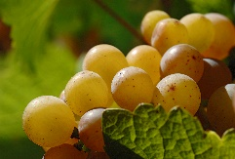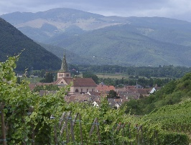

Gewurztraminer Tradition

