**Appellation :** AOC ALSACE

**Grape variety :** Pinot Blanc et Auxerrois

Pinot Blanc (apples, flowery, creamy) – Pinot Auxerrois (musky, buttery, spicy, honeyed, apricot, orange blossom, tangerine peel) two varieties of the same family, traditionally vinificated together.

**Soil :** Limestone, granite, gravel, marl and sandstone

**Vinification :** Traditional in stainless steel tank, fermentation temperature of 19°C.

**Analysis :** vintage 2022

Alcohol % : 13 %

Residual Sugar g/l : 1.7

Total Acidity g/l H2So4 : 3.50

Volatile Acidity g/l H2So4 : 0.23

**Quality and character :**

This Pinot Blanc has a light yellow –green colour. The nose is very fresh and fruity, witn note of fresh pear, apple, white peach. Elegant and easy to drink are the main caracteristics of this beautiful pinot blanc.

**Temperature of service :** 8 to 10°c

**Prime drinking :** 2 to 3 years

**Food matching**Fish, seafood, shellfish, poultry, entrees, pork, picnics, salads, pastry, or serve just as an aperitif. The Pinot Blanc can be served to any occasion which needs a nice dry white wine.

EAN bouteille : 3 274 550 310 750

EAN carton : 3 274 550 310 743

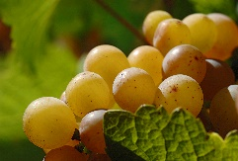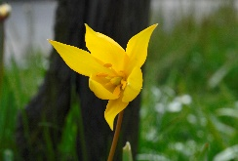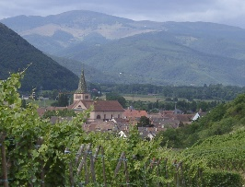

Pinot Blanc Tradition

