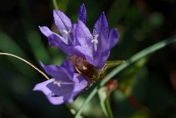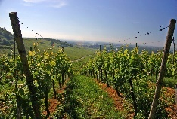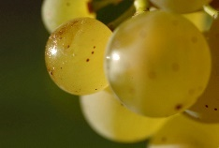

**Appellation :** AOC ALSACE

**Grape variety :** 100 % Pinot Gris

This pink grape, coming from Burgundy, produces a high sugar level and has aromatic flavour.

**Soil :** Limestone, granite, gravel, marl and sandstone

**Vinification :** Traditional in stainless steel tank, fermentation temperature of 19°C.

**Analysis :** vintage 2022

Alcohol % : 13%

Residual Sugar g/l : 8.2

Total Acidity g/l H2So4 : 3.54

Volatile Acidity g/l H2So4 : 0.16

**Quality and character :**

Light yellow in colour, has a lovely perfumed nose with White flowers notes, as well as peach and abricot, very attractive. This Pinot Gris is off-dry.

**Temperature of service :** 8 to 10°c

**Prime drinking :** 2 to 3 years

**Food matching**Aperitif, fish or shellfish, white meat, exotic cuisine.

**Previous rating  :**

Vintage 2016 : 86 points Wine Enthusiast

Vintage 2017 : 89 points Wine Enthusiast

Vintage 2018 : 89 points Wine Enthusiast

EAN bouteille : 3 478 886 789 000

EAN carton : 3 478 887 711 987

Pinot Gris Découverte

