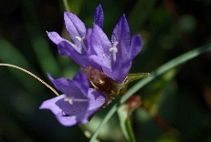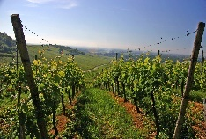

**Appellation :** AOC ALSACE

**Grape variety :** 100% Pinot Noir

The only red grape in Alsace, either in refreshing Rosé or silky red depending on the wine making process.

**Soil :** Limestone, gravel, marl and sandstone

**Vinification :** Stainless steel tanks, temperature 22°, malo lactic fermentation

**Analysis :** vintage 2022

Alcohol % : 12.28%

Residual Sugar g/l : 0.2

Total Acidity g/l H2So4 : 4.30

Volatile Acidity g/l H2So4 : 0.51

**Quality and character :**

This Pinot Noir has a typical red fruit nose (cherries). Dry and elegant, pinot noir red wine.

**Temperature of service :** 14 to 16°c

**Prime drinking :** 2 to 3 years

**Food matching :** Grilled meat, sausages, fish, salads

Pinot Noir Découverte

