**Appellation :** AOC ALSACE GRAND CRU BRAND

**Grape variety :** 100 % Riesling

This grape, originated in Germany, was first recorded in Alsace in 1477, the Riesling was the first Alsace wine to develop its own identity and is considered by most today as the region’s most classic variety.

**Soil :** The Brand (burnt) slope in Turckheim is an abrupt slope with a full south exposure. Dry and granit soil, one of the very best situations in Alsace.

**Vinification :** Traditional in stainless steel tank, fermentation temperature of 19°C.

**Analysis :** vintage 2018

Alcohol % : 13 %

Residual Sugar g/l : 6.3g/l

Total Acidity g/l H2So4 : 4.02

Volatile Acidity g/l H2So4 : 0,36

**Quality and character :**

Light yellow in colour, with a rich perfumed of grapefruit and citrus fruit. This riesling is elegant, rich, dry with plenty of fesh citrus fruit and a touch of minerality, balanced with a pleasant acidity giving it a long mouth finish. Can be drunk now but has also a great ability to age.

**Temperature of service :** 8 to 10°c

**Prime drinking :** 5 to 20 years

**Food matching**: Seafood such as Oysters, shellfish, smoked salmon, Fresh schrimp, Lobster and fish. But poultry and white meat are also excellent with it.

**Rating :** 93 points Decanter 2023

2017 : 94 points Wine Enthusiast

2015 : 95 points Wine Enthusiast

2013 : 95 points Decanter

2012 : 92 points Wine Enthusiast

EAN bouteille : 3 274 550 560 469

EAN carton : 3 274 550 560 407

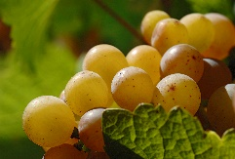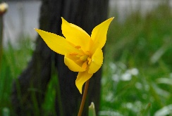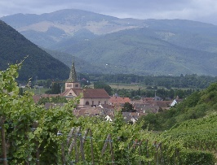

Riesling Grand Cru Brand

