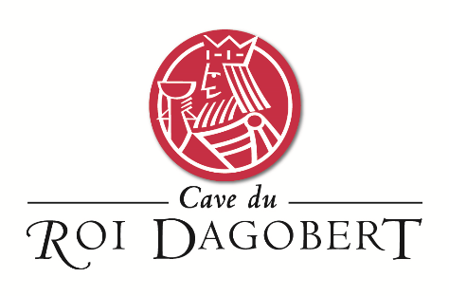

**Appellation :** AOC ALSACE

**Grape variety :** 100% Riesling

This grape originated in Germany and was first recorded as the Riesling in Alsace in 1477, it is considered by most today as the region’s most classic variety.

**Soil :** This riesling is made with grapes coming from our best terroirs : Marl, Limestone, clay and sandstone soils.

**Vinification :** Traditional in stainless steel tank, fermentation temperature of 19°C.

**Analysis :** vintage 2021

Alcohol % : 12 %

Residual Sugar g/l : 2.6

Total Acidity g/l H2So4 : 6.16

Volatile Acidity g/l H2So4 : 0.28

**Quality and character :**

The 2020 vintage provides great concentration and intensity. This fruity Riesling shows flavours of lime, grapefuit and vervain with a long mouth finish. The diversity of soils brings elegance and minerality.

**Temperature of service :** 8 to 10°c

**Prime drinking :** 4 to 5 years

**Food matching**Its very fine acidity suits very well to fish, shellfish, every seafood plate. Not to forget poultry and white meat and goat cheeses

**Ratings  :**

Vintage 2013 commended by Decanter WWA in 2015

Vintage 2014 : 90 points Wine Enthusiast, Gold medal Gilbert et Gaillard 2016

Vintage 2015 : 93 points Wine Enthusiast , Gold Medal Paris 2017

Vintage 2016 : 91 points Wine Enthusiast , Gold Medal Colmar 2017

Vintage 2018 : 90 points Wine Enthusiast

Vintage 2019 : 90 points Wine Enthusiast

Riesling Racines et Terroirs

