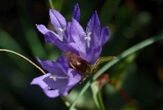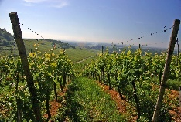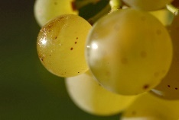

**Appellation :** AOC ALSACE

**Grape variety :** 100% Riesling

This grape originated in Germany and was first recorded as the Riesling in Alsace in 1477, it is considered by most today as the region’s most classic variety.

**Soil :** Sandy and gravely soil

**Vinification :** Traditional in stainless steel tank, fermentation temperature of 19°C.

**Analysis :** vintage 2021

Alcohol % : 12.5%

Residual Sugar g/l : 2.1

Total Acidity g/l H2So4 : 5.5

Volatile Acidity g/l H2So4 : 0.21

**Quality and character :**

Fresh and clean citrus aromas are followed on the palate by a dry purity of lime fruit with subtle mineral edge. A long and pleasant mouth mouth.

**Temperature of service :** 8 to 10°c

**Prime drinking :** 4 to 5 years

**Food matching**Its very fine acidity suits very well to fish, shellfish, every seafood plate. Not to forget poultry and white meat and goat cheese.

EAN bouteille : 3 274 550 522 160

EAN carton : 3 274 550 522 108

Riesling Selection

