**Appellation :** AOC ALSACE

**Grape variety :** 100% Riesling

This grape originated in Germany and was first recorded as the Riesling in Alsace in 1477, it is considered by most today as the region’s most classic variety.

**Soil :** Limestone, granite, gravel, marl and sandstone

**Vinification :** Traditional in stainless steel tank, fermentation temperature of 19°C.

**Analysis :** vintage 2022

Alcohol % : 12.5%

Residual Sugar g/l : 2.4g/l

Total Acidity g/l H2So4 : 4.90

Volatile Acidity g/l H2So4 : 0.15

**Quality and character :**

Light green in colour. Perfume of citrus, grapefruit, exotic fruit. The taste is delicately fruity (citrus and grapefruit), long and crispy. A well balanced pleasant acidity that gives a long mouth finish.

**Temperature of service :** 8 to 10°c

**Prime drinking :** 2 to 3 years

**Food matching**Its very fine acidity suits very well to fish, shellfish, every seafood plate. Not to forget poultry and white meat and goat cheese.

EAN bouteille : 3 274 550 510 761

EAN carton : 3 274 550 510 709

**Rating :**

2017 : 90 points Wine Enthusiast Magazin

2016 : 89 points Wine Enthusiast Magazin

2015 : 90 points Wine Enthusiast Magazin

2017 : 90 points Wine Enthusiast Magazin

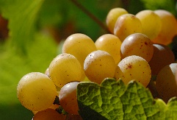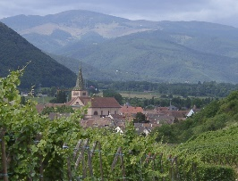

Riesling Tradition

