**Appellation :** AOC ALSACE

**Grape variety :** 100 % Riesling

This grape originated in Germany and was first recorded as the Riesling in Alsace in 1477, it is considered by most today as the region’s most classic variety.

**Soil :** Collection Terroir is made from the best terroirs surrounding the winery (Granit, Sand and pebbles, limestone), allowing the best expression of each grapes.

**Vinification :** Traditional in stainless steel tank, fermentation temperature of 19°C.

**Analysis :** vintage 2022

Alcohol % : ?

Residual Sugar g/l : ?

Total Acidity g/l H2So4 : ?

Volatile Acidity g/l H2So4 : ?

**Quality and character :**

This Riesling is dry and shows flavours of lemon and vervain with a long fresh mouth finish. The diversity of soils brings elegance and minerality.

**Temperature of service :** 8 to 10°c

**Prime drinking :** 4 to 5 years

**Food matching :**Its very fine acidity suits very well to fish, shellfish, every seafood plate. Not to forget poultry and white meat and goat cheese.

EAN bouteille : 3 274 550 551 269

EAN carton : 3 274 550 551 207

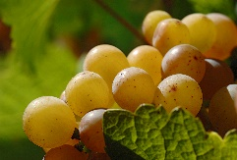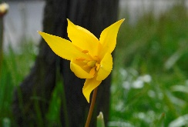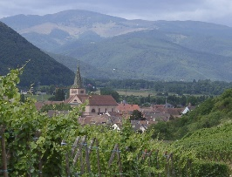

Riesling Collection Terroirs

